Press Kit
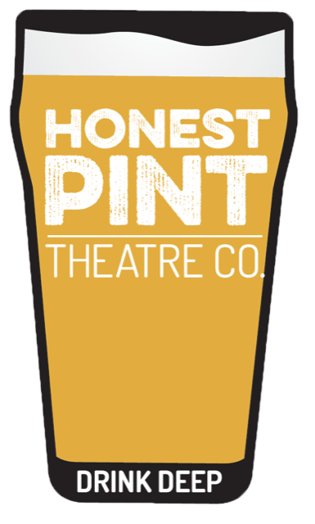

“If it’s the hard stuff you’re after,
Honest Pint has plenty to pour…”

– Independent Weekly

“The reason to see this production is that it’s
damn good theater… Some moments are so surprising and shocking that I gasped audibly...”
— Dustin K. Britt, Triangle Arts & Entertainment (HAMLET)
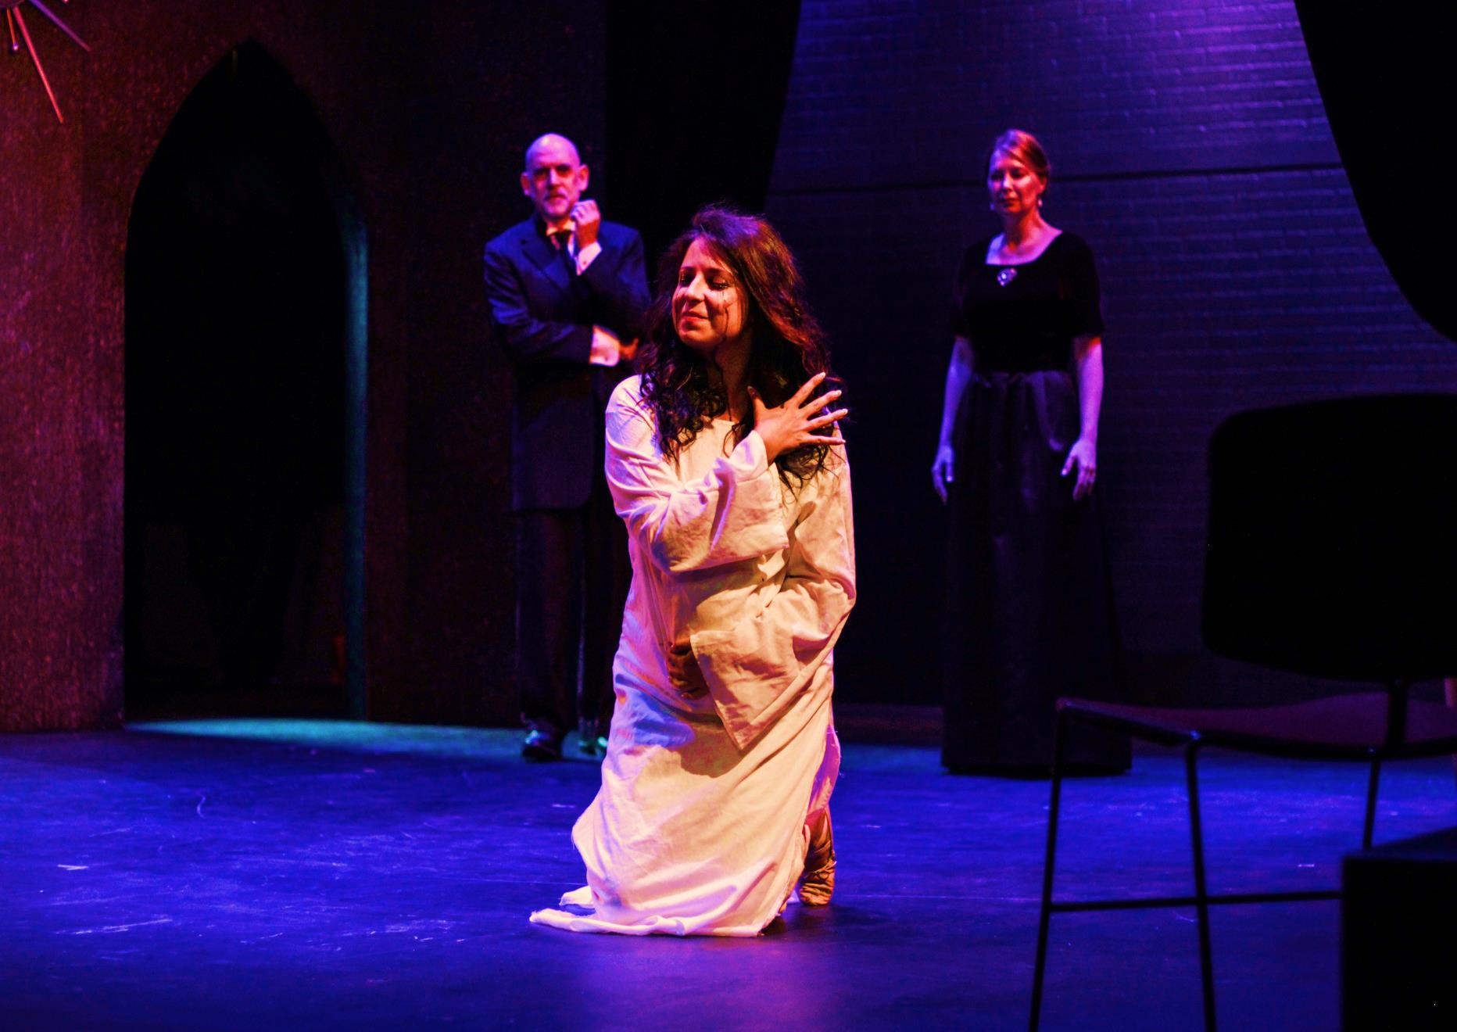

Photo by Megan Dohm

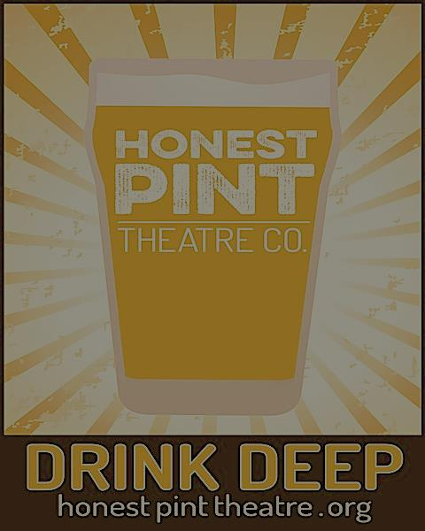
WHO WE ARE

Honest Pint Theatre Company is a professional theatre company established in 2013 and located in Raleigh, NC. Our inaugural offering was a critically acclaimed production of A STEADY RAIN by Keith Huff. Our 2015 production of Sharr White’s ANNAPURNA won awards for Set Design, Acting, and Best Drama at the Inaugural Triangle Theatre awards. In the few years since, Honest Pint produced the critically acclaimed production of William Shakespeare's HAMLET (UNCUT) and the regional premiere of THE NIGHT ALIVE by Conor McPherson, which was hailed by critics as the season’s most satisfying production and one of the top five productions of 2017 in the Triangle. In September 2017, audiences roared for their production of KING LEAR and critics lauded their November 2018 production of THE MYSTERY OF LOVE & SEX. April of 2018 brought THE ABSOLUTE BRIGHTNESS OF LEONARD PELKEY, which had audience members coming back multiple times to experience the show. Critics called it “masterful.” In January 2019, we produced THE HERD by Rory Kinnear, to raving critics and audiences, and were only the third company in the U.S. to produce this harrowing and heartfelt piece of theatre. Spring of 2019 brought THE LEGEND OF GEORIGA MCBRIDE, a story of “logical family” and finding your place in the world in places you’d least expect. The show had audiences and critics cheering, hollering, and throwing dollar bills, with their cheeks sore from laughing for 2 hours! Fall of 2019 will bring David Ives' THE METROMANIACS, with which we hope to continue our legacy of sidesplitting and thought-provoking theatre!

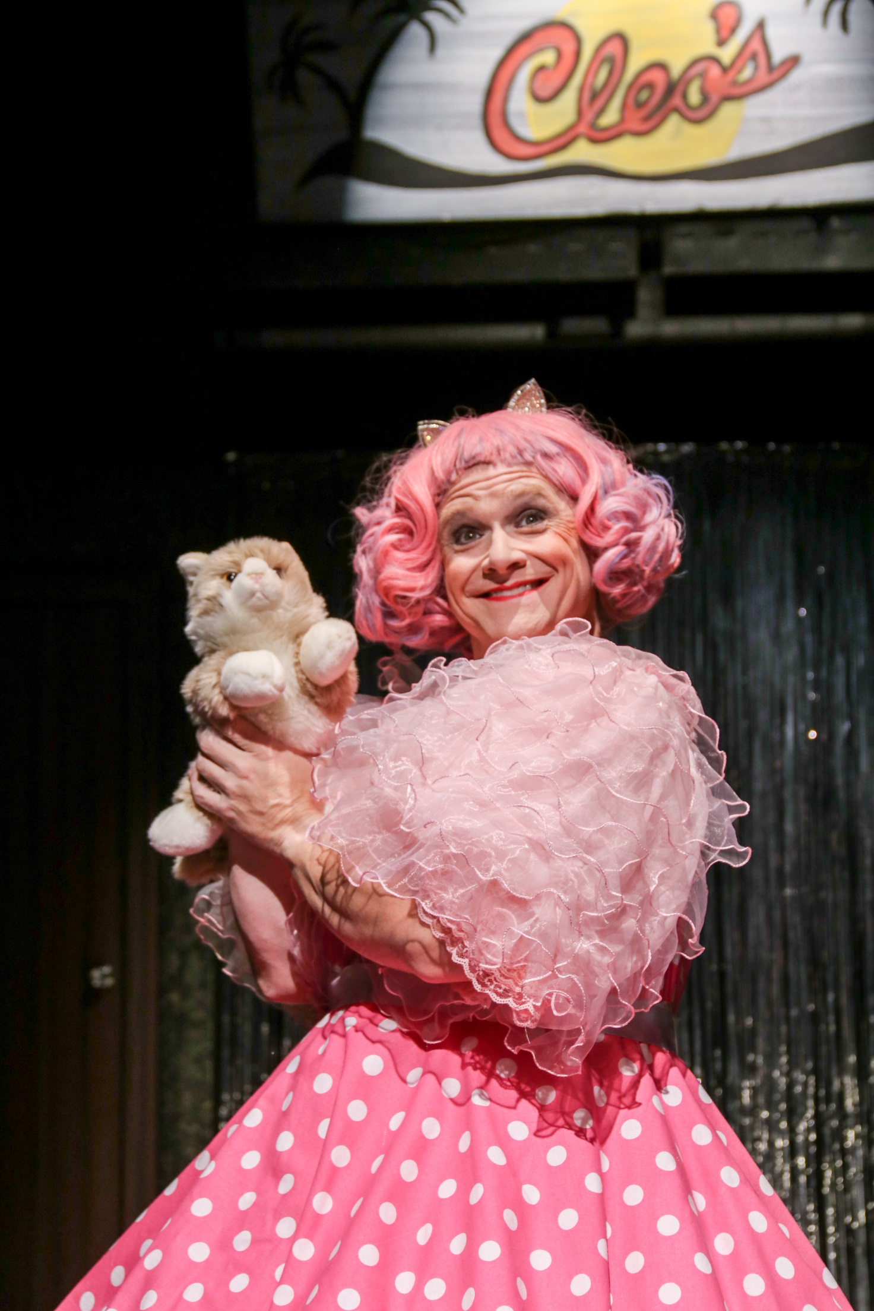
Photo by Areon Mobasher

“Henderson commands the stage in a powerhouse performance…only enhanced by a seemingly endless arrangement of facial expressions.”
--Melanie Simmons, Triangle Arts & Entertainment

What’s an Honest Pint?
Our name stems from the UK concept of an honest pint of beer: a 16 fluid ounce pour—no foam, no skimping. Exactly what the drinker paid for. Our mission is based on the idea that audience members should get exactly what they pay for—the highest-quality storytelling that we can bring them—and the opportunity to experience it with peers in a safe, welcoming environment. We honor this commitment in three specific ways: creating community-centered experiences; nurturing Triangle-area artists; and producing challenging works of theatre that linger with audiences long after they leave the show.

Photo by Areon Mobasher
“Honest Pint deserves much credit for mounting this demanding show with such audience-pleasing results.”
--Roy Dicks, CVNC

Simon Kaplan’s Lear is, indeed “every inch a king.” (KING LEAR)
-- Kurt Benrud, Triangle Arts & Entertainment
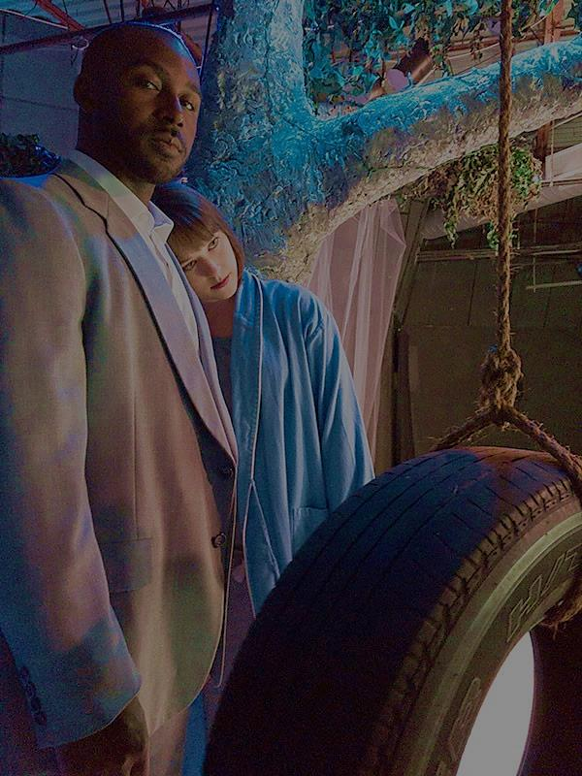

“Honest Pint Theatre Company’s staging is another success
in its string of intimate, adult-themed productions.”
-- Roy Dicks, Raleigh News & Observer
(THE MYSTERY OF LOVE & SEX)
Photo by Susannah Hough

Who’s Who at Honest Pint
Susannah Hough – Co-Artistic Director
Susannah Hough hails from Los Angeles but has called the Triangle home for many years now, and is a veteran of numerous stage and film companies here. Some favorite roles are: ANNAPURNA (Honest Pint Theatre Co.), THE NIGHT ALIVE (Director), THE ABSOLUTE BRIGHTNESS OF LEONARD PELKEY (Director); hmlt (HAMLET), RICHIE, THE NEW COLOSSUS (Little Green Pig Theatrical Concern); BODY AWARENESS, SUPERIOR DONUTS (Deep Dish Theater Co.); ALWAYS…PATSY CLINE (REP); OUR TOWN, THE GRAPES OF WRATH (Justice Theater Project); LOST IN YONKERS (Raleigh Little Theatre); DEARLY BELOVED (Theatre in the Park); DADDY’S DYIN’, THERE GOES THE BRIDE (Theatrefest). She has appeared in the short films Righteous (Bombshell Studios), Endings (Turnip Films), and Katie’s Dog (Carbon Footprint), as well as numerous commercials, industrial videos, and TV. She coaches young actors for auditions and teaches acting classes, as well. Training: For a complete resume go to: www.susannahhough.com

David Henderson – Co-Artistic Director and Founder
David Henderson is a Morehead Scholar graduate of UNC-Chapel Hill. Most recently, he was seen in Honest Pint’s one-man show, THE ABSOLUTE BRIGHTNESS OF LEONARD PELKEY. Prior to that, he played Doc in THE NIGHT ALIVE, and played the title role in HAMLET, which earned him the Broadway World award for Best Actor in a Play. He also starred as Sweeney in SWEENEY TODD at RLT and understudied the role for Playmakers Repertory Company. Favorite roles include: Ulysses in ANNAPURNA, Joey in A STEADY RAIN, Fr. Laurence in ROMEO AND JULIET, Edward in SOMEONE WHO’LL WATCH OVER ME, Mitch in TUESDAYS WITH MORRIE, Bottom in A MIDSUMMER NIGHT’S DREAM, and Henry in HENRY V. For the past 23 years, he has had the pleasure of playing Jacob Marley in Theatre in the Park’s annual production of A CHRISTMAS CAROL.
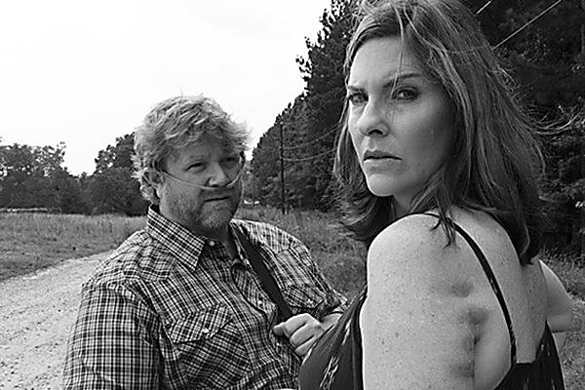
Photo by Alex Maness
“The power and grace seen in this production makes it easily among the best plays that we have ever seen. … The acting is absolutely spot-on. … This is acting at its finest.”

— Pamela Vesper and Kurt Benrud, Triangle Arts & Entertainment (ANNAPURNA)

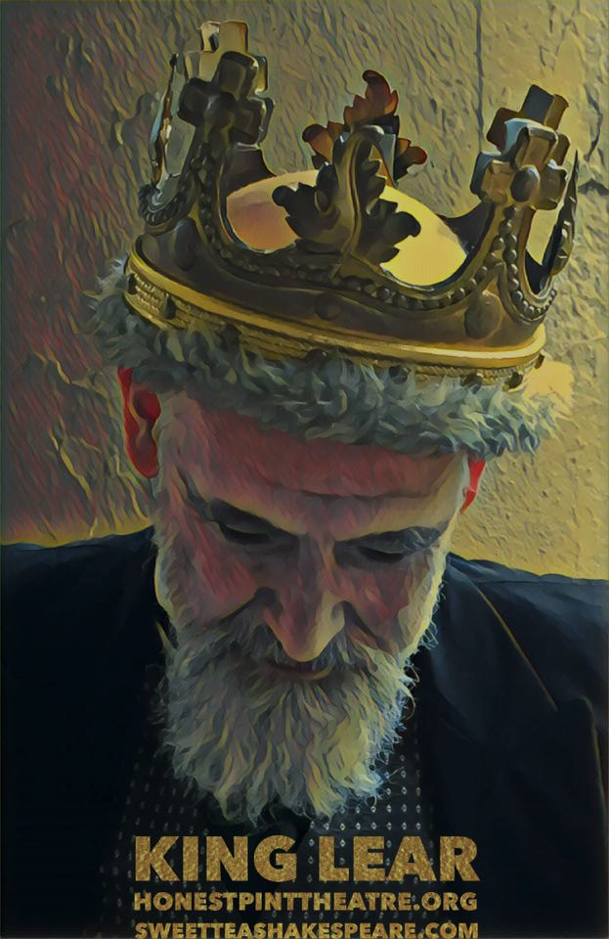
Photo by Susannah Hough

“One of the finest Triangle productions of the last few seasons…”
-Dustin K. Britt, Triangle Arts & Entertainment
(KING LEAR)

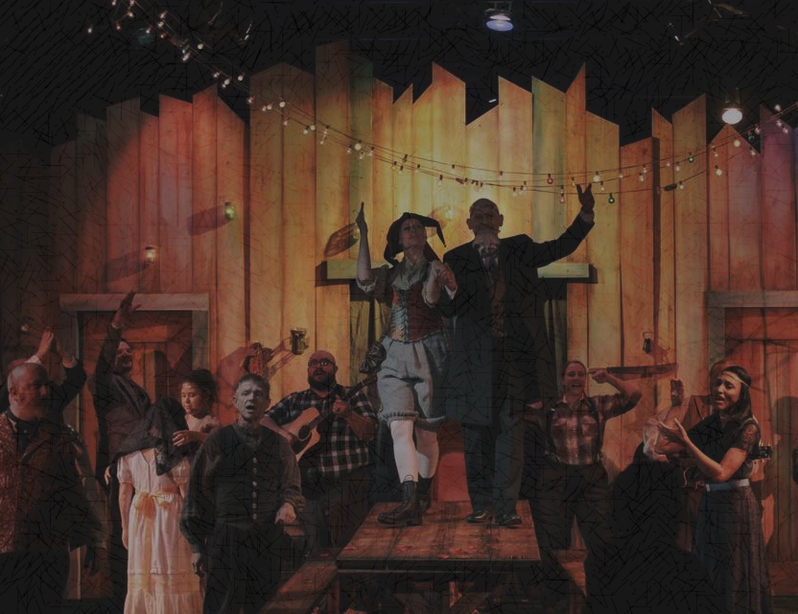
Quick Facts
- Founded in the summer of 2013
- Inaugural production was A Steady Rain by Keith Huff
- As of today, we have produced 9 full-length, critically-acclaimed plays
- Guest directors have included Glenn Matthews, Jeremy Fiebig, and Dana Marks
- Earned over 30 positive reviews since inception, and have been featured in Walter Magazine, on WUNC, BroadwayWorld.com, RaleighMag.com, and others
- Annapurna won Best Set Design, Best Acting, and Best Drama at the Triangle Theatre Awards
- In addition to full-length productions, we run the Home Brew series--a chance to feature NC artists and creators of all sorts sharing stories, music, films, plays, and new works in an intimate, social atmosphere.

Photo by Susannah Hough

Photo by Curtis Brown

“This production serves as a perfect example of
live theater’s spellbinding power
and emotional thrust.”
- Roy C. Dicks, Raleigh News & Observer (A STEADY RAIN)
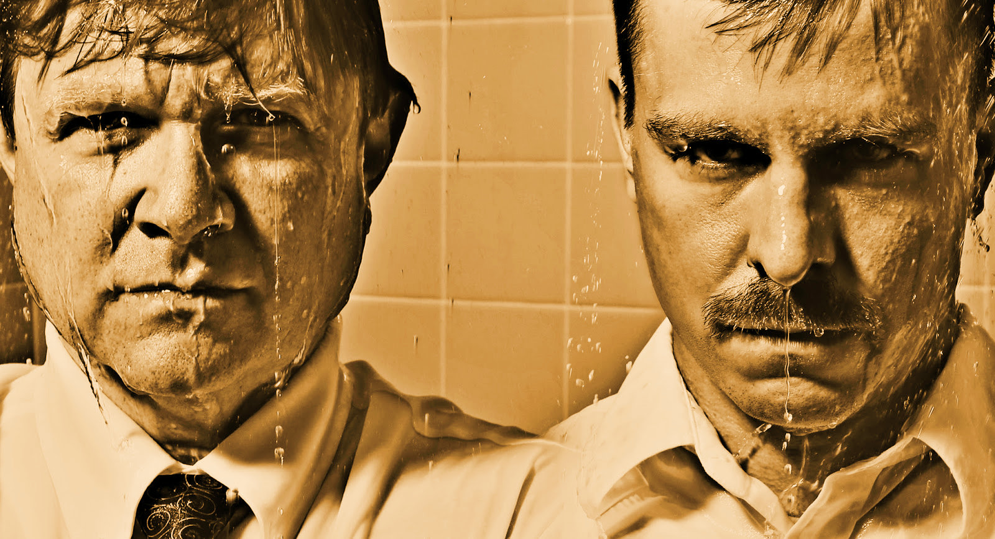

Photo by Curtis Brown
Where We’re Heading…
Theatre has the power to illuminate, transform and heal. We know that live theatre is an essential part of the cultural richness of a community, and that participating in community events enriches the quality of our personal lives, our families, and the quality of our work. A big part of our goal is making sure that we give back to the community that has made us possible. A few of our next steps will be:

- Enabling Honest Pint to produce shows across North Carolina.
  - Culturally underserved areas in our region need to see and hear some of the stories that we tell. We would love to be able to share them with people in eastern and western NC.
- Increasing actor/director/tech stipends
  - This allows us to use local artists and create a community that can earn hard-earned wages making art.
- Subsidizing ticket costs for students and young adults who otherwise would not be able to afford a ticket a live Honest Pint show.

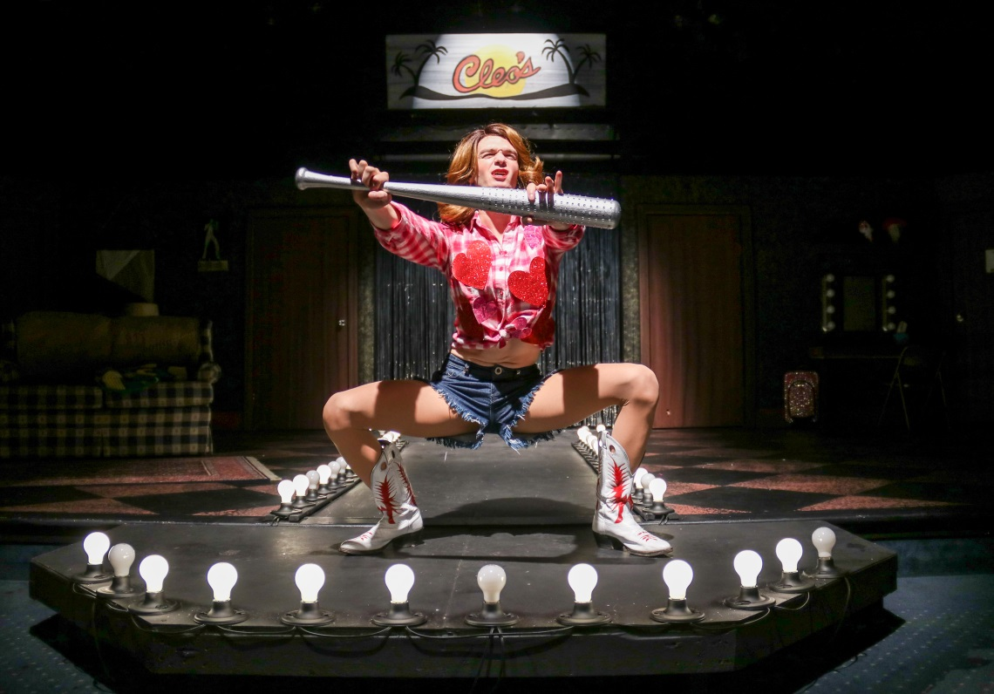

“Honest Pint’s rendition of The Legend of Georgia McBride might be the best entertainment in the Triangle at the moment, easily living up to Honest Pint’s reputation for producing some of the best shows in town.”
— Melanie Simmons, Triangle Arts & Entertainment

Photos by Areon Mobasher
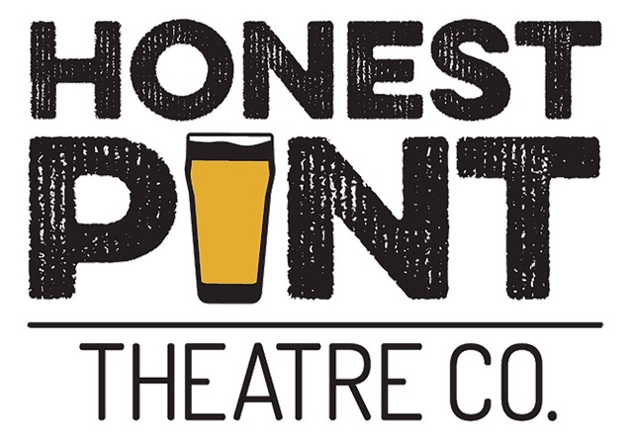
Photo by Areon Mobasher

Please visit our website to learn more:
www.honestpinttheatre.org

On our website under the “Press” tab you will find performance photos, links to full reviews, and more.

@honestpinttheatre
@HonestPintthe8r
@HonestPintTheatreCompany
Honest Pint Theatre
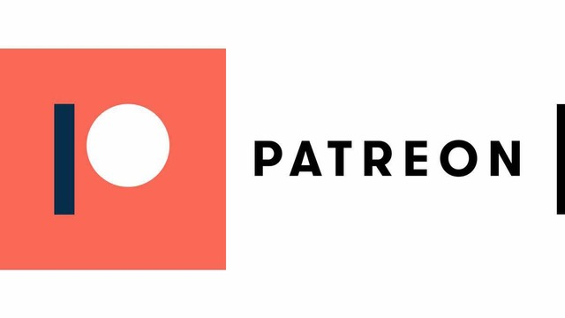 www.patreon.com/honestpinttheatre

